COMP1536 Website Development Project

Website design practices and reasons

-Proper choice of colour for contrast (black with white for text) and accessibility

-Balanced selection of images to aid navigation and make the site visually appealing

-Content arranged into grid design to keep content organized

-Following coding conventions and validating our code through w3C for compatibility

-Well researched and recent content to attract and keep visitor traffic

Wireframe: Catalogue Detail Page

Two Column Fluid

Page width: 800px

Page height: free

Color Scheme: #000000, #a9a9a9, #ffffff

Our design will be good for practice of floating box model design.

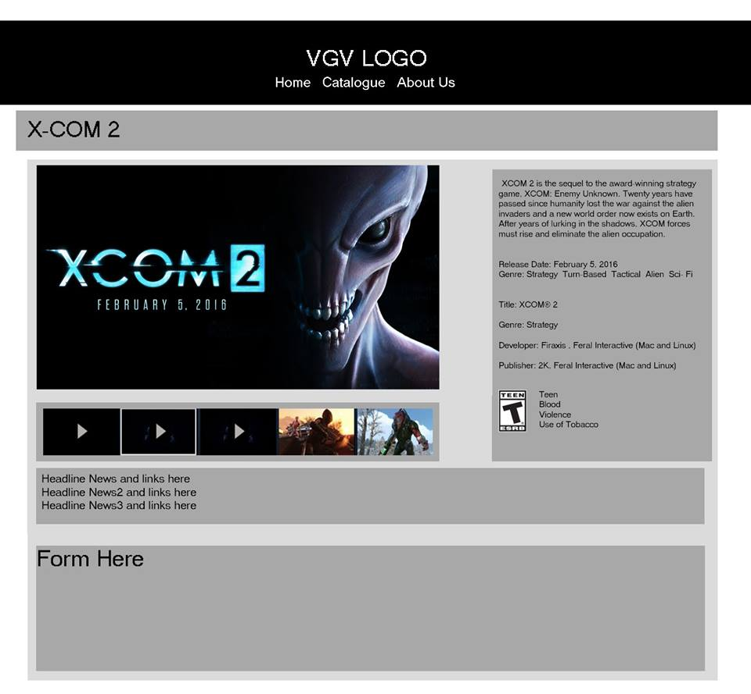

Catalog Index

4 Column Fluid

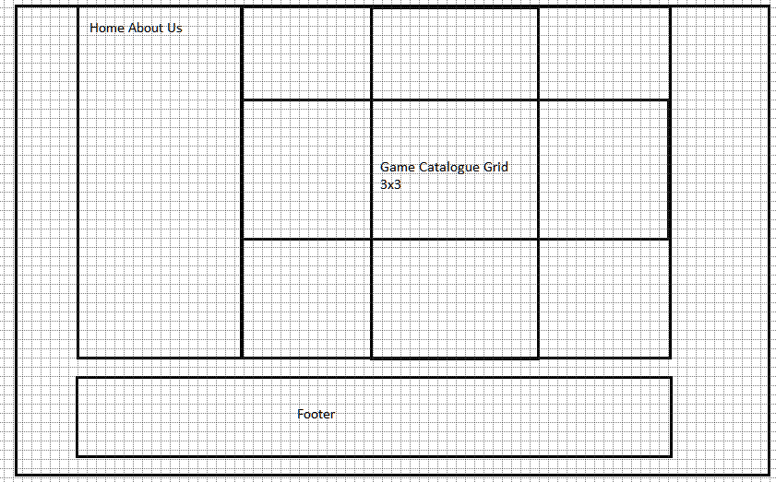

Wireframe: News page

One Column Fluid

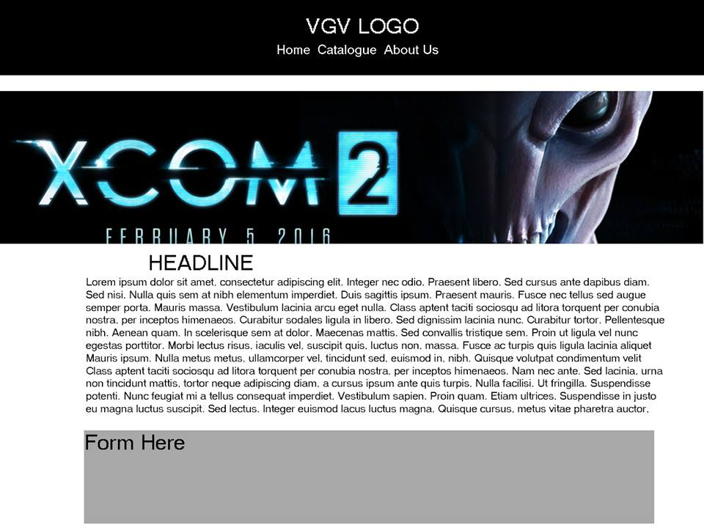

Wireframe: Policy and Staff Page

Two Column Fluid

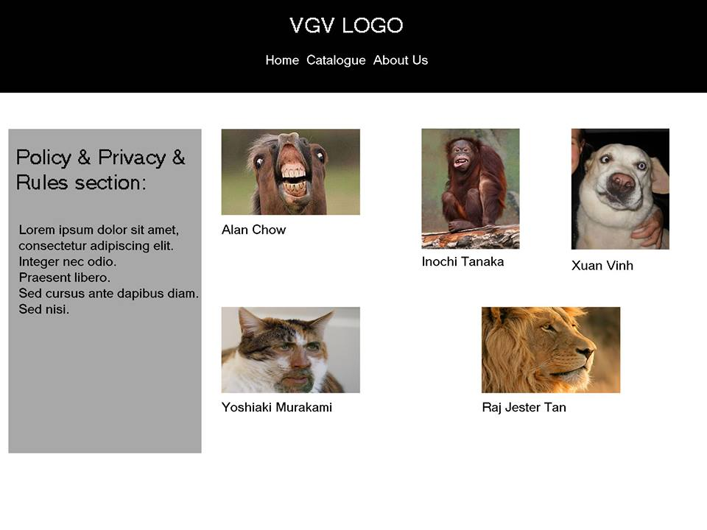

Wireframe: Top Page

Three Column Fluid

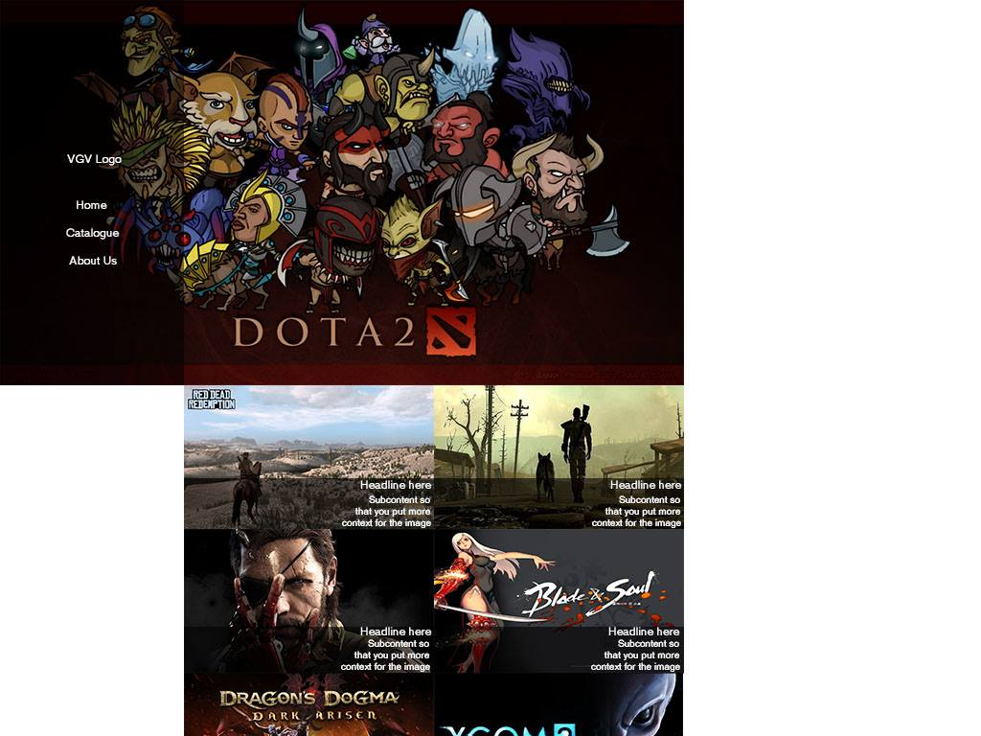

Wireframe: Registration Page

One Column Fluid

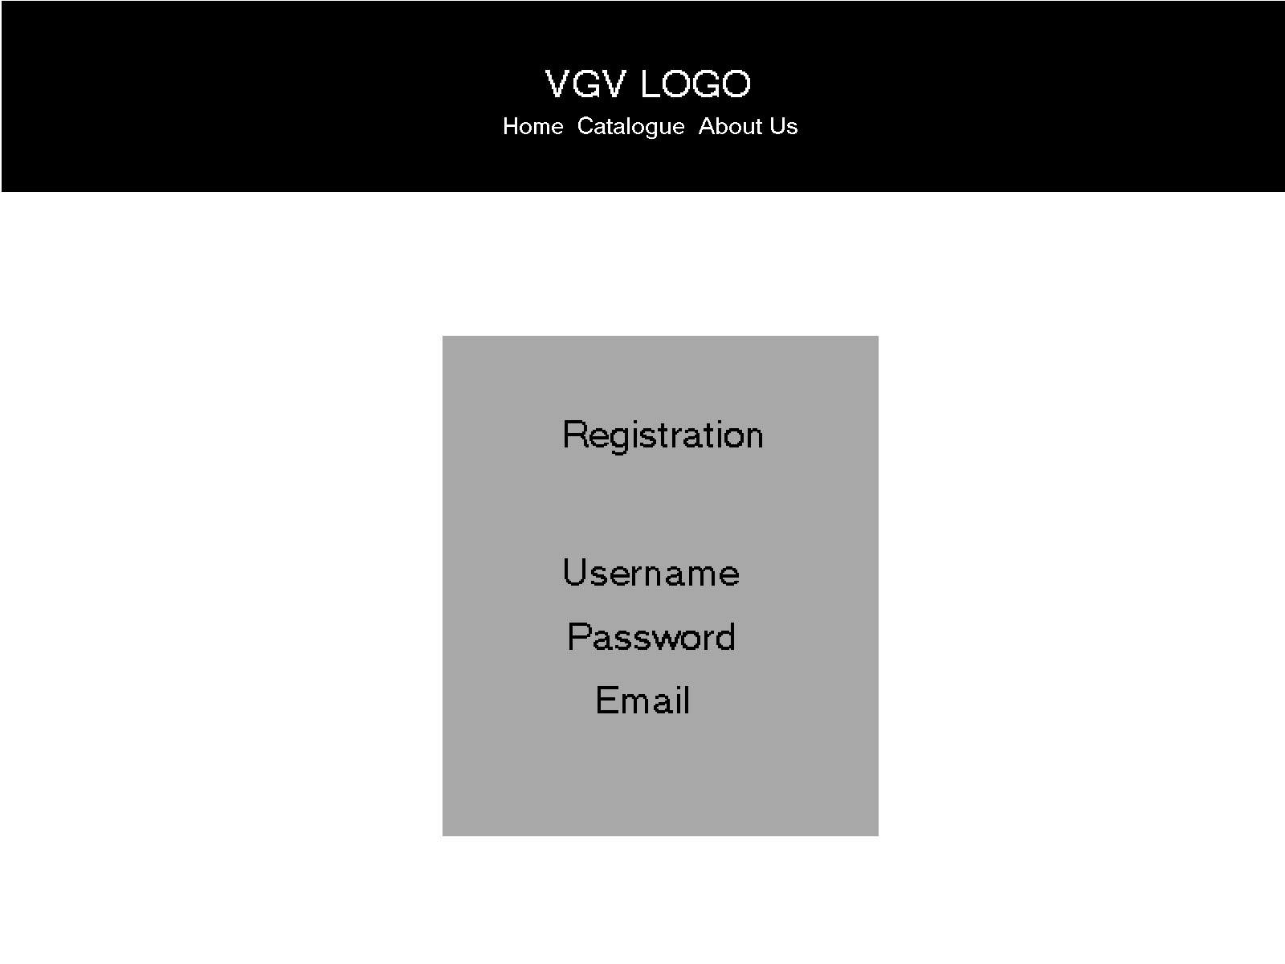

Wireframe: Thank you page



Sitemap



Print Layout

Index

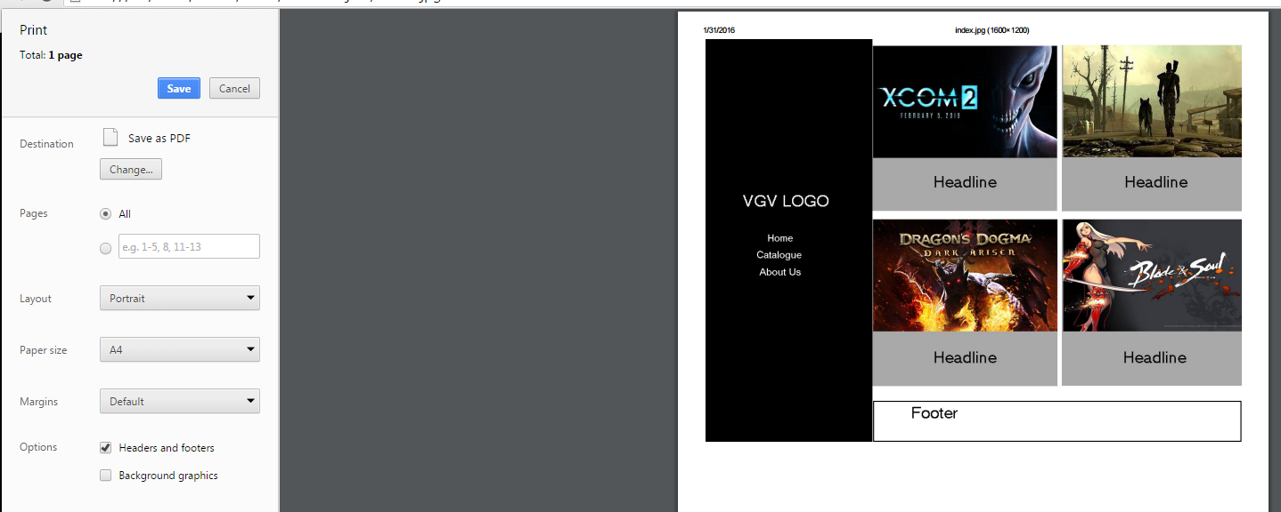

COMP1536 Website Development Project

Revised Project Proposal

Purpose, needs served

The purpose of our website is to deliver up to date and interesting PC gaming news, PC game reviews and coverage of the latest releases. Our website will serve the needs of gamers who want coverage of the latest games and diverse viewpoints on new developments in the industry.

Goals

Communication and community. We want to create a community for gamers and provide them with important and relevant information from the gaming industry as a service.

Target Audience

This website will be built for those who are in the 18 and older age group, and read English proficiently.

Accomplishments Needed

The website needs to provide up to date material in the PC gaming industry in a form accessible from both computers and mobile devices. In addition, it must provide a platform for visitors to interact and form a community. Finally, the website must also have a visually appealing design balancing selected images with our chosen colour scheme.

Content

The website will be structured as a game catalogue. Related news, reviews, forums and media will be placed into the pages that each catalogue entry is linked to. We will also have separate pages that link from the index for our privacy and policies page and for user registration process.

Success Factors

Retaining and growing a community, and good presentation of information will be the main factors for success.

Similar Websites and CritiqueIgn, Gamespot and Kotaku are sites that are similar to our project. We like the websites listed, and hope to design ours to a similar level.

Functional Requirements

We will have registration forms on our website for our forum. A list will also be made to organize PC game titles we discuss on our site.

Work-plan

We will be meeting during school breaks, and online through social networking applications as needed. Our meeting schedule is outlined in the table below.

We will meet deadlines by maintaining communications, developing our skills diligently, and sharing our knowledge, experience and time to complete assigned tasks whenever necessary.

|  |  |  |  |  |  |  |
| --- | --- | --- | --- | --- | --- | --- |
| Sunday | Monday | Tuesday | Wednesday | Thursday | Friday | Saturday |
|  | 12:30 PM-3:30 PM | 1:30 PM-2:30 PM | Starting 2:30 |  | 11:30 PM-12:30 PM |  |

AB Test

Background image



Background no image

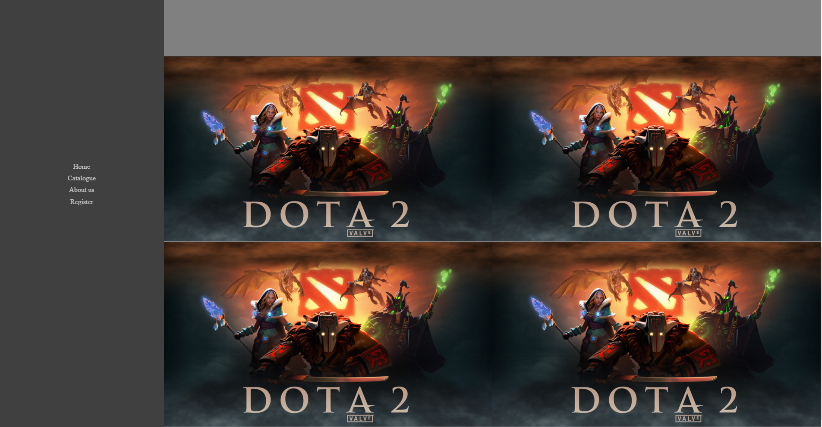

Background image

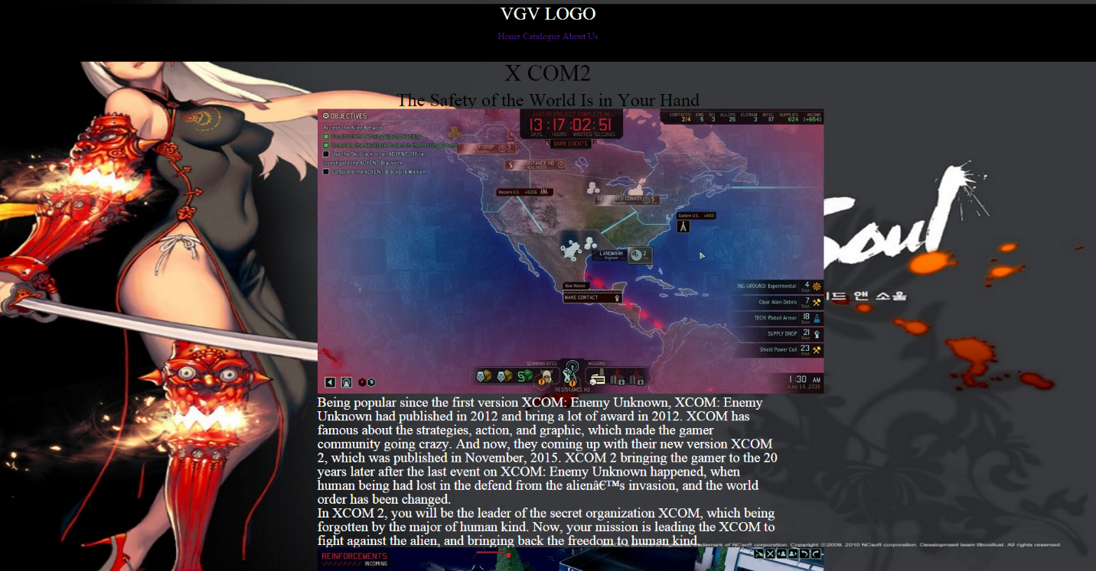

Background no image

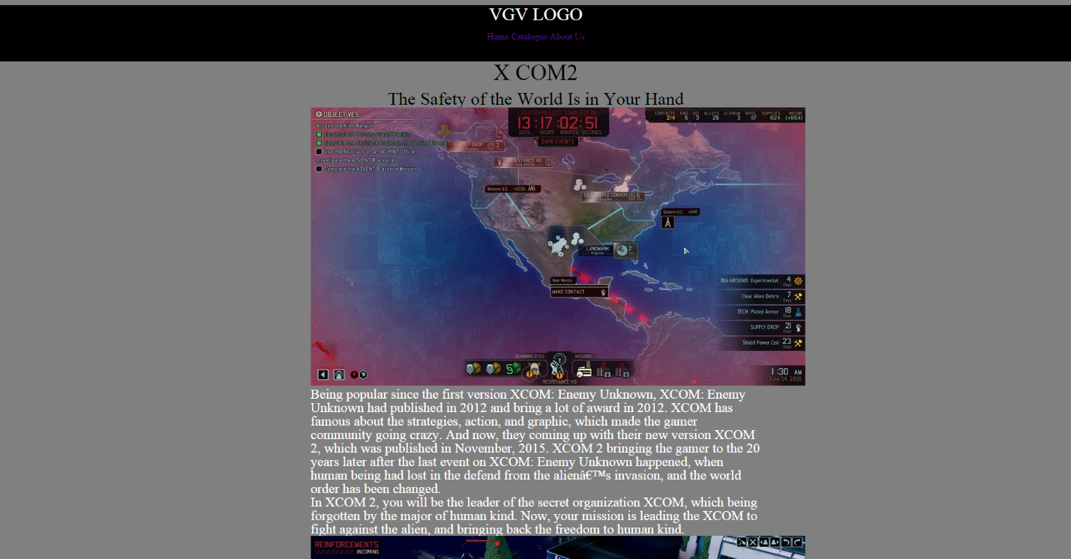

Background image

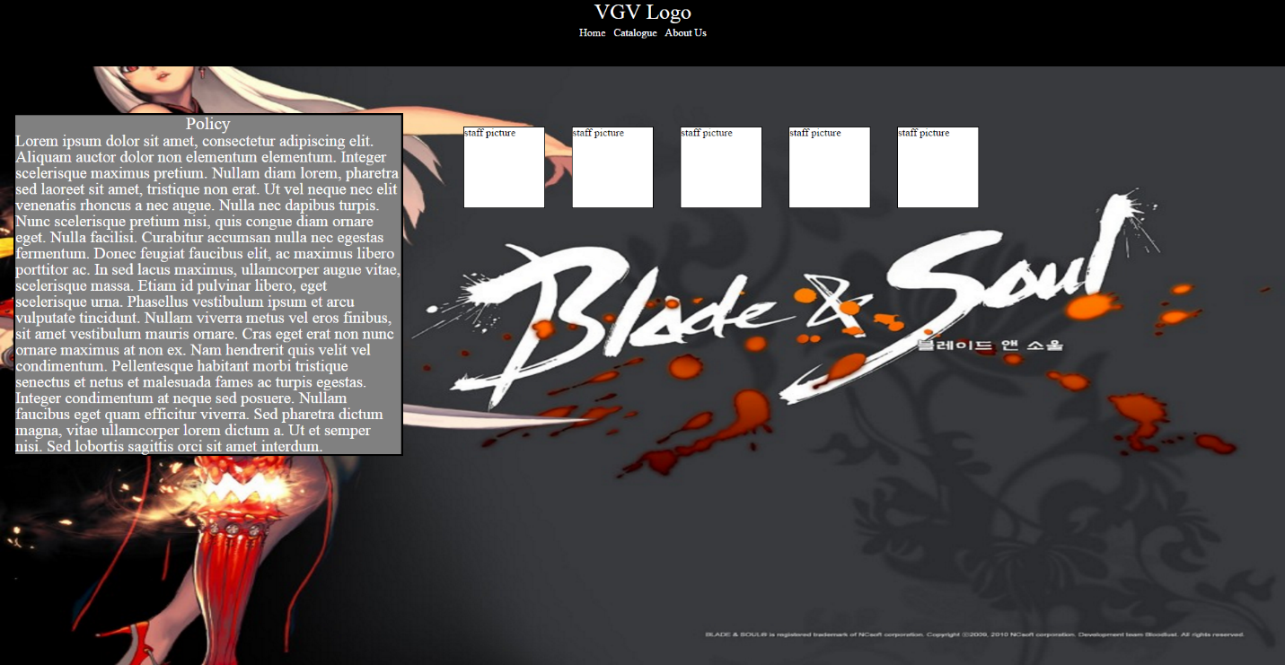

Background no image

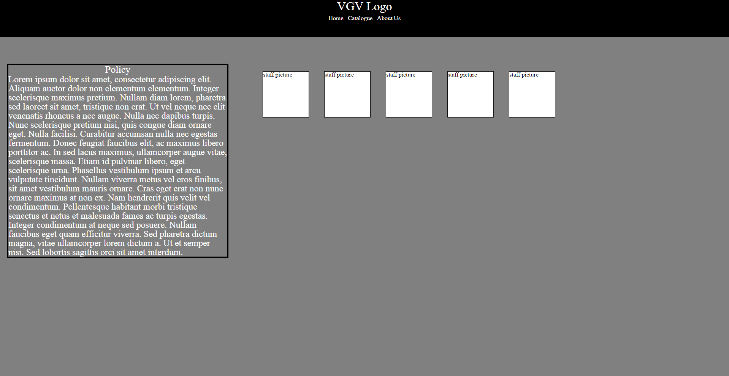

Background image

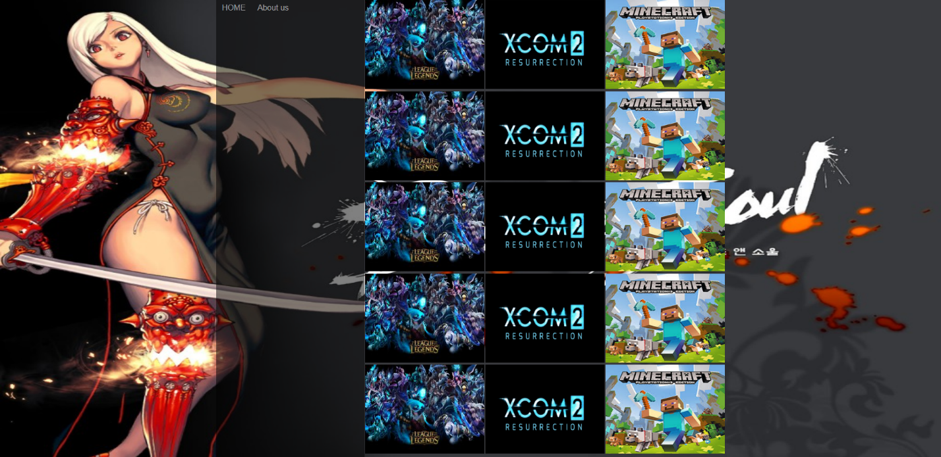

Backgournd no image

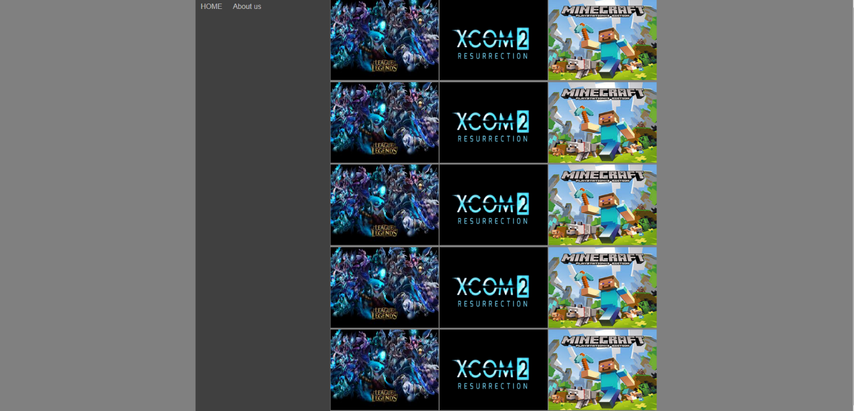

Background image should be used on all web pages.